 **2D ANIMATION FINAL PROJECT REVIEW:**

***NAME:*** *PREETI RACHEL JASPER*

***REG NO:*** *17BCS0003*

**TITLE:** The donkey and his masters

**TEAM MEMBERS:** Preeti Rachel Jasper

**IDEA:**

The age old fable of **The donkey and his masters** is a story that has resonated with me since my childhood. It brings to light the difficulties of being a labour worker, never being content with your life. The story highlights the consequences of thinking that the “Grass is greener on the opposite side.” Hence, the story teaches one to be content and happy with the life they have.

**STORY BOARD:**

Once upon a time there lived a donkey.

His master sold herbs in the market.

The donkey had to work very hard each day.

But his master wanted the donkey to work harder.

The donkey was not happy with his master.

He had to work too much.

Yet the master only gave him a little bit of food.

The donkey decided he had enough.

He did not want to work for his master any longer.

There was only one person who could help the donkey.

The donkey searched for Jupiter, the god of the sky and rain.

"Please give me a new master," begged the donkey.

The donkey explained why he wanted a new master.

"I will give you a new master," Jupiter said finally.

"But," Jupiter said firmly, "you will regret making this wish."

The donkey was too happy to care.

"I will give you a new master," Jupiter said finally.

"But," Jupiter said firmly, "you will regret making this wish."

The donkey was too happy to care.

The donkey's new master was a brick-maker.

The donkey had to pull heavy carts of brick every day.

The donkey's master wanted him to work harder.

He did not give the donkey any food or water.

The donkey realised his wrong doing.

He was hungry and thirsty, always tired as well.

He finally repents and decides to kill himself.

The work load was too much for him.

On his way to the bridge to jump off, sees the God of Jupiter again.

The God asks if he understood his mistake.

The donkey cries and apologises.

The God feels bad and returns the donkey to his old master.

Happy ending, as the donkey is now content.

**ANIMATION METHODS:**

Frame by frame animation methof has been used for the implemenattion of this story. Flash easily supports this method, depedning on the type of animation you wish to create. Even though motion and shape tweens help you create animations that maybe quick and efficient, you may find that the possibilities are quite limited. Frame by frame animation is more time-consuming and complex to create but can afford more detail and flexibility that you can’t otherwise achieve.

To create a **frame by frame** animation , follow these steps:

1. Create a new flash document to work in.
2. Create a blank keyframe for each frame you want toinlcudee in your animation . You can do this easily by clicking a frame and using f7 shortcut key.
3. Draw ( or insert ) a graphic for each state of your animation on the appropriate keyframes.
4. Play back your animation by pressing enter or return.
5. In some cases, you can break artwork into individual ,moving parts ( like wheels or a bicycle) across several layers to frame by frame by using motion tweens.

**IMPLEMENTATION:**

Creating the buttons:

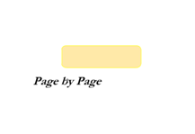

Creating the symbols:

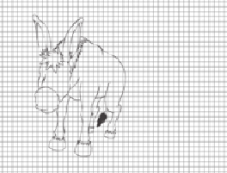

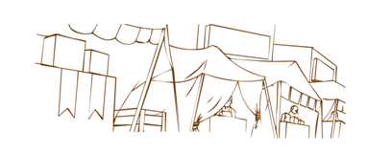

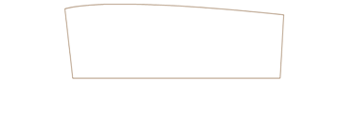

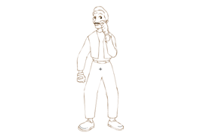

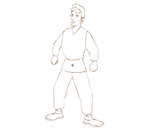

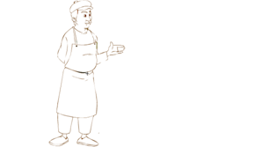

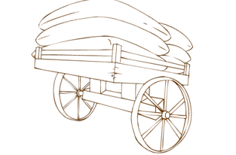

Changing symbols to create facial expressions:

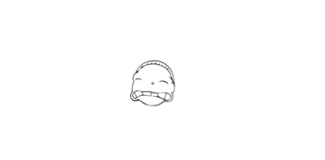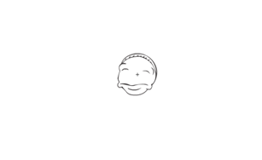

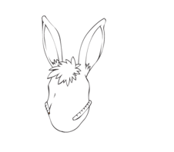

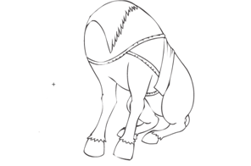

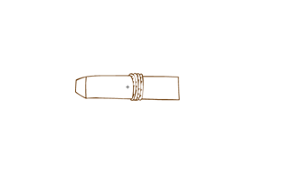

Coloring in the symbols:

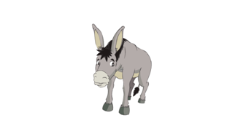

SCREENSHOTS:

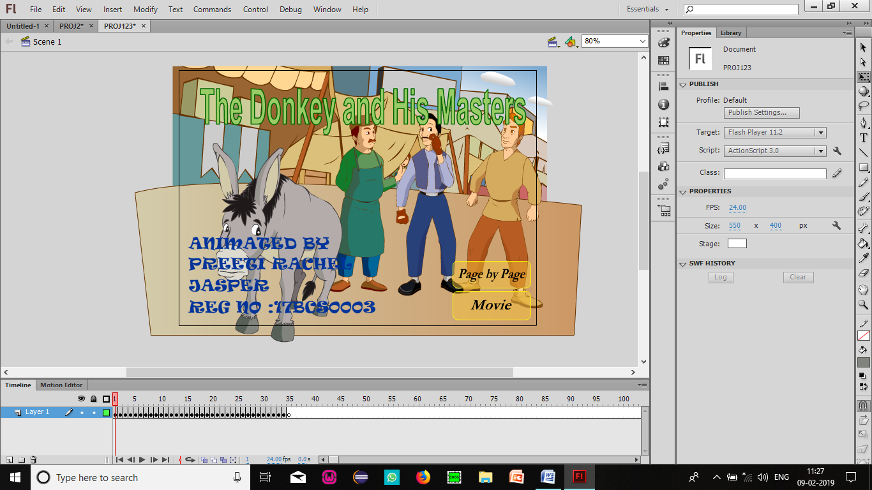

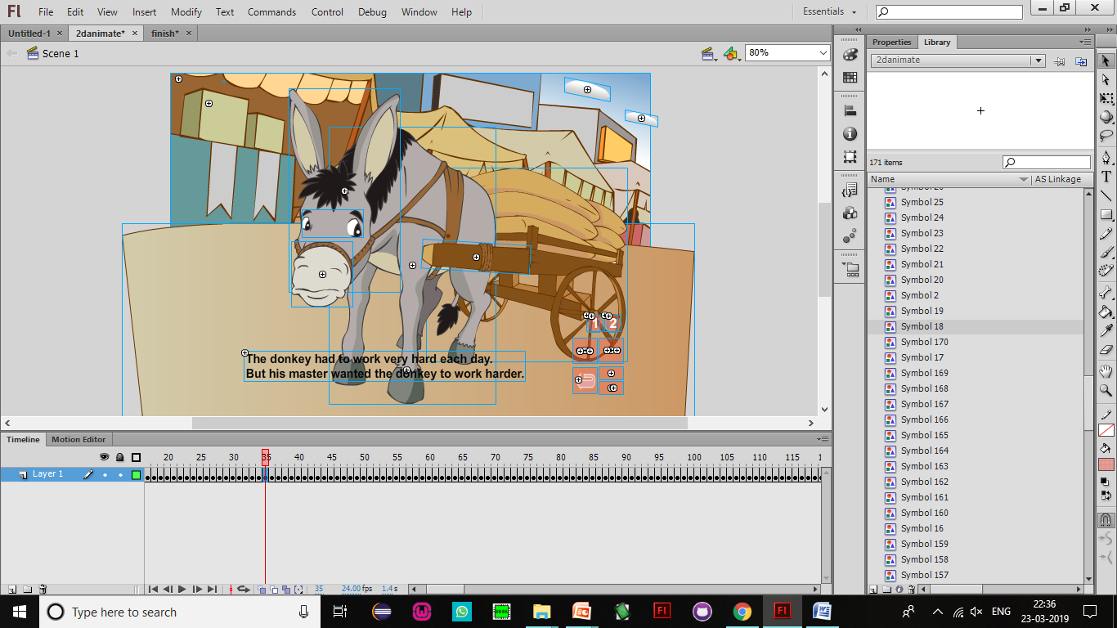

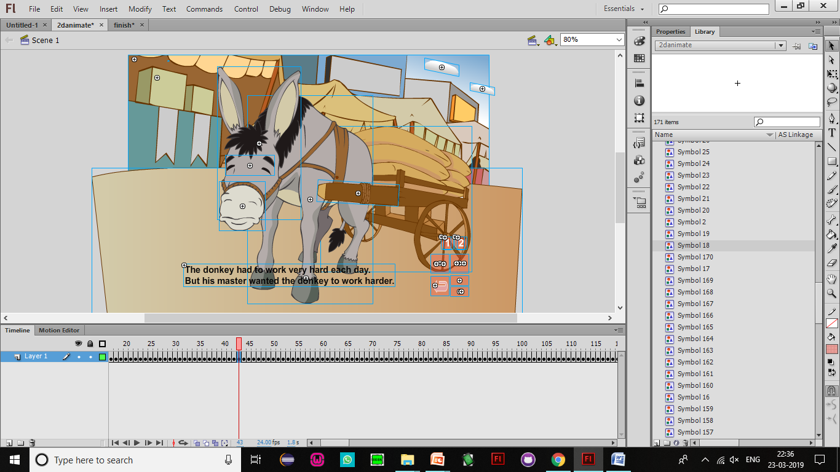

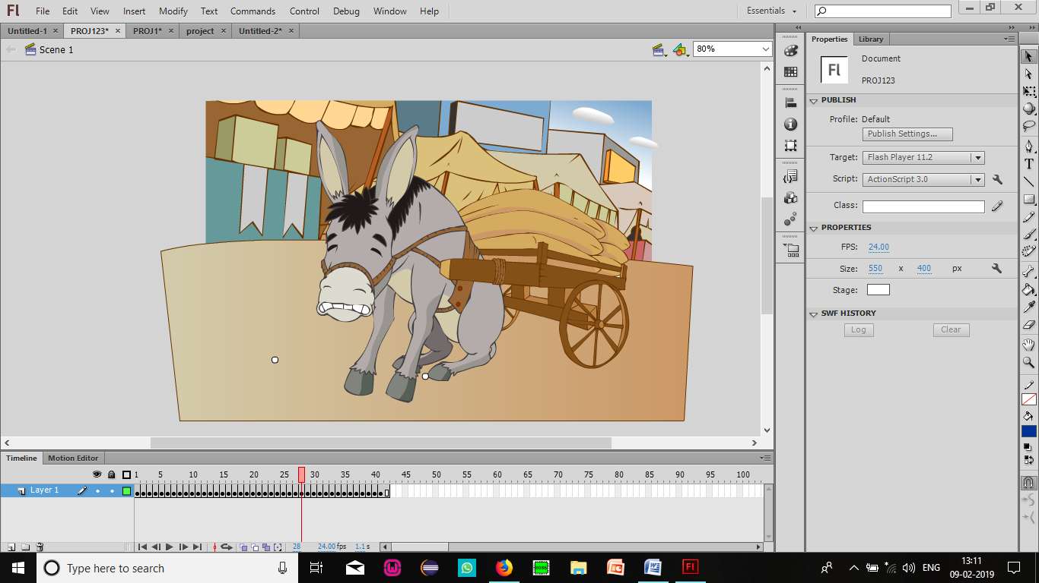

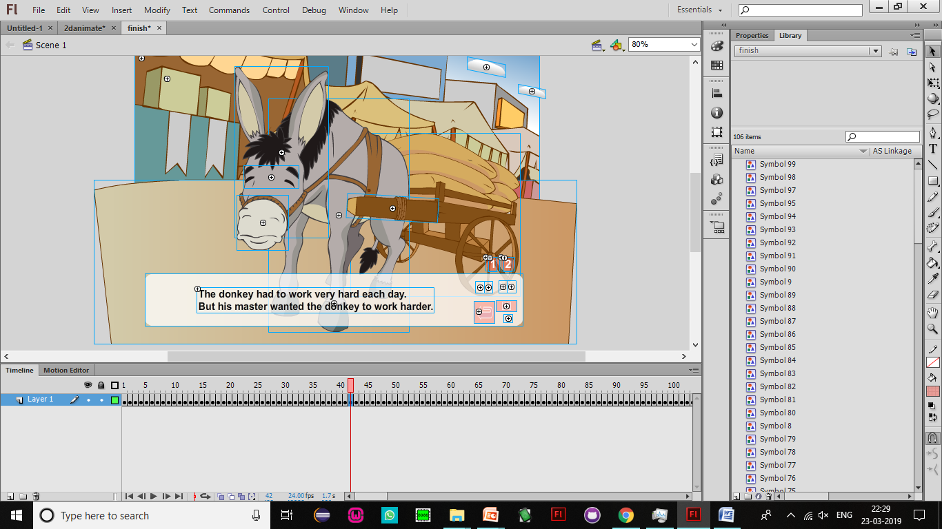

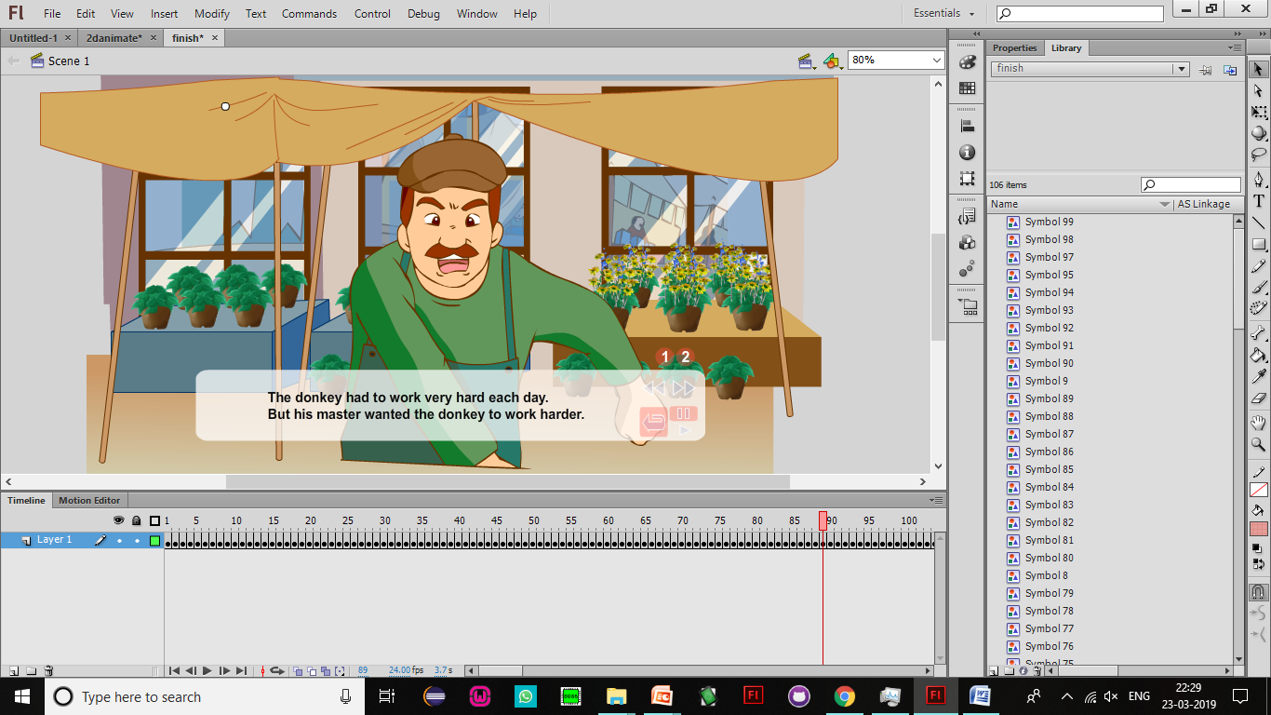

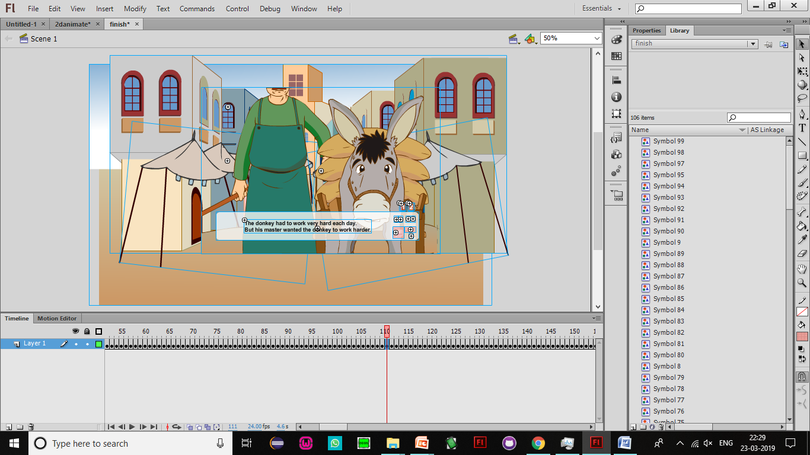

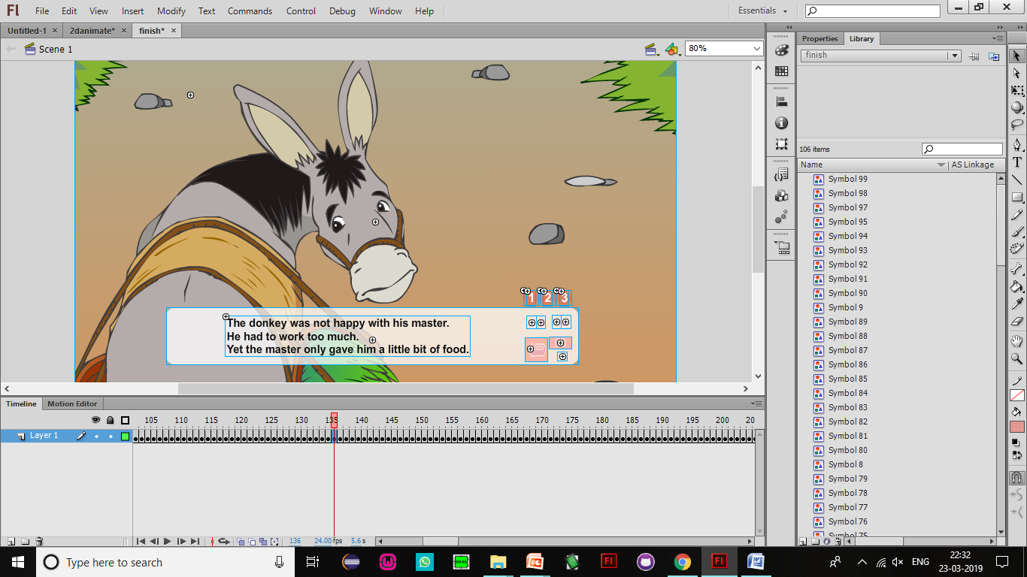

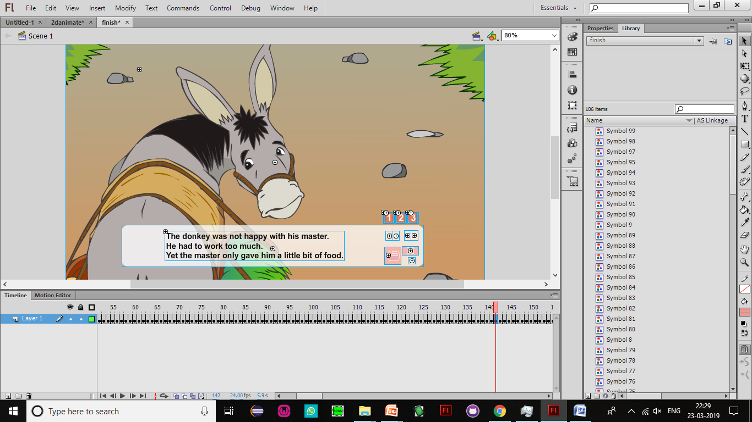

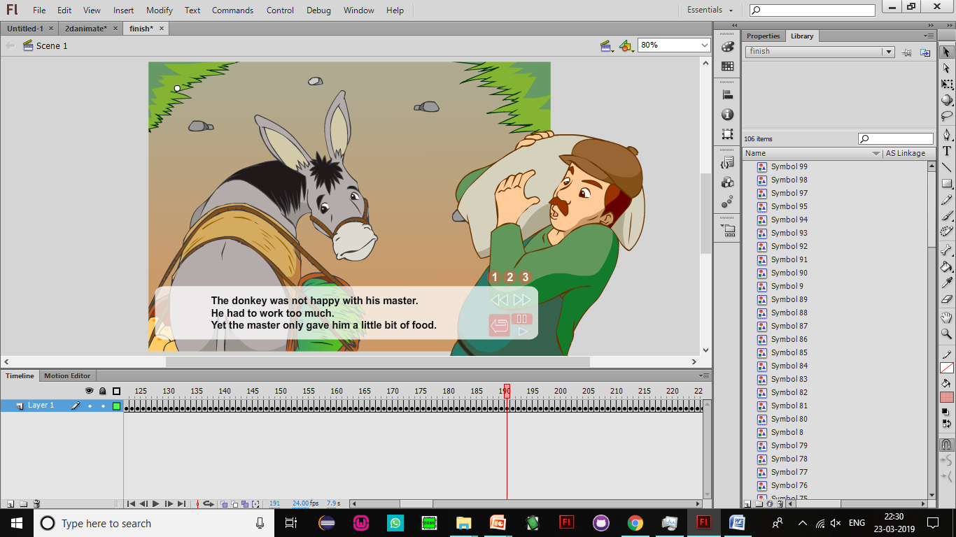

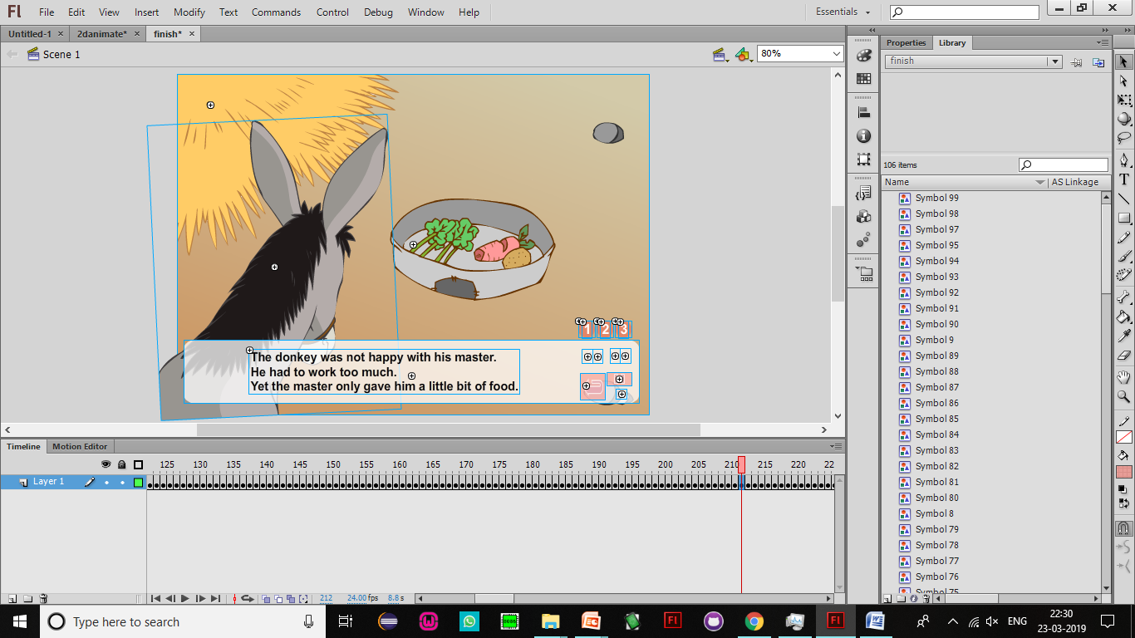

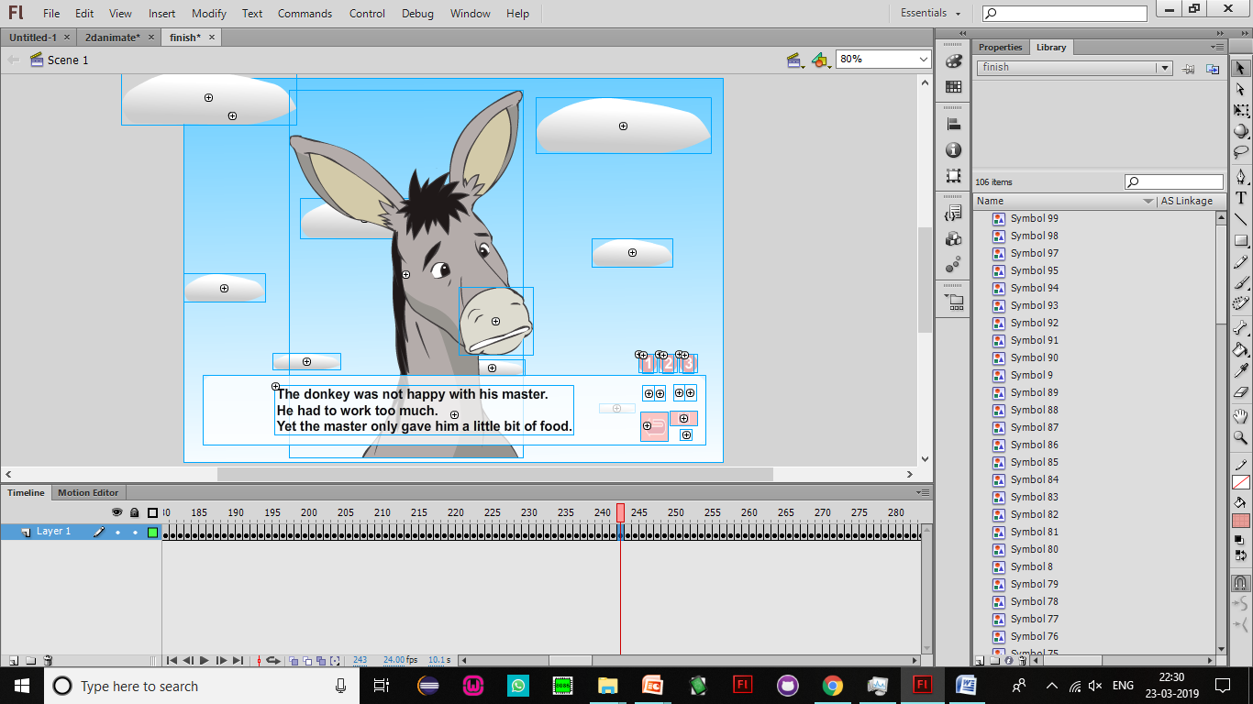

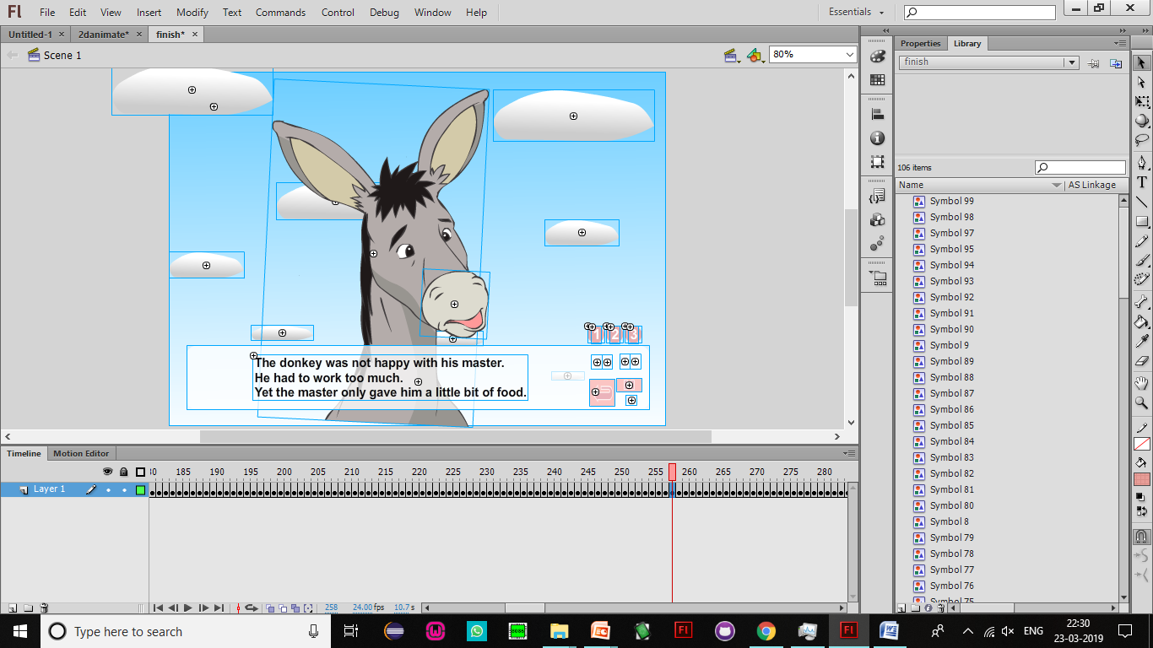

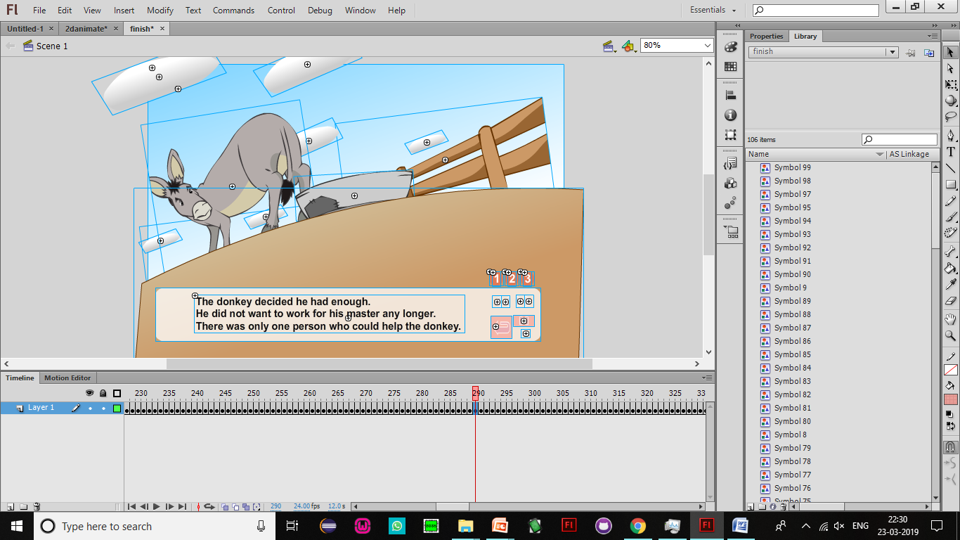

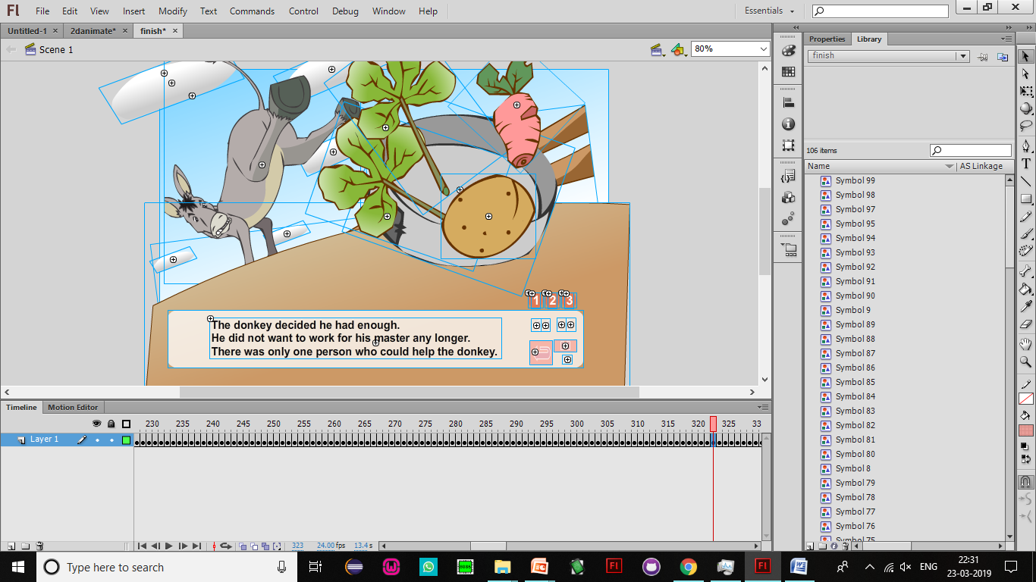

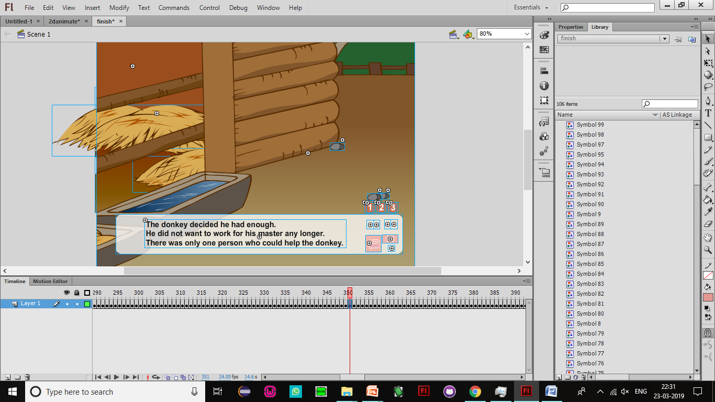

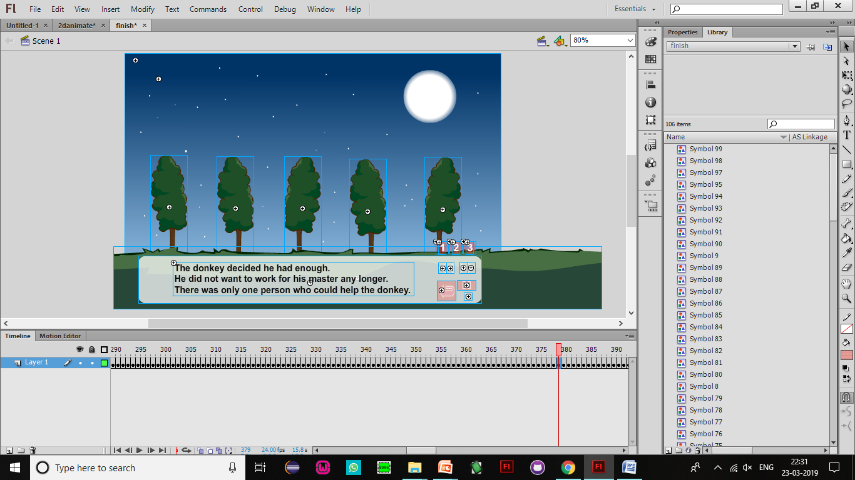

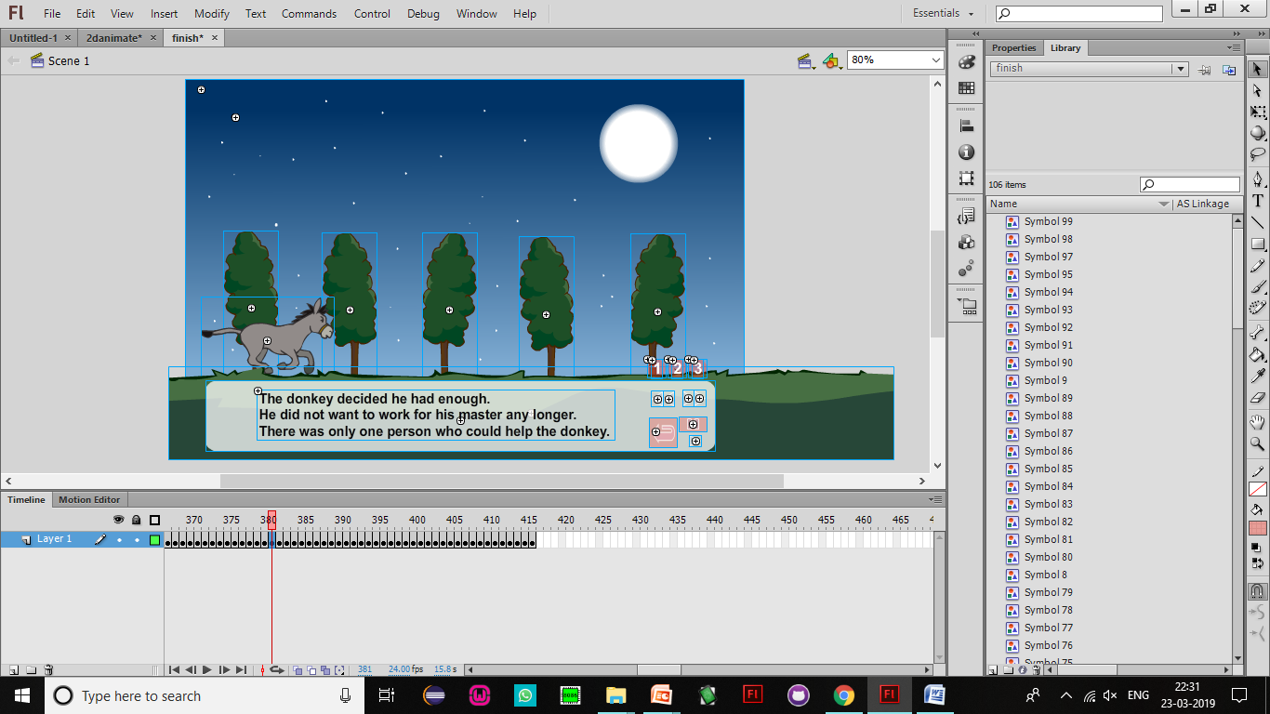

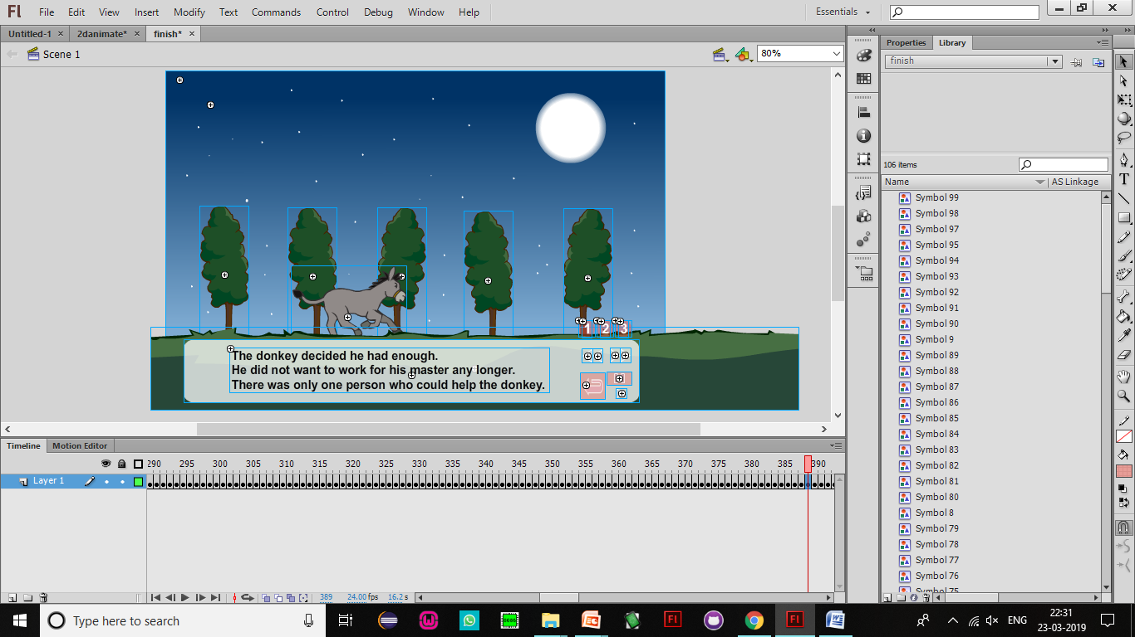

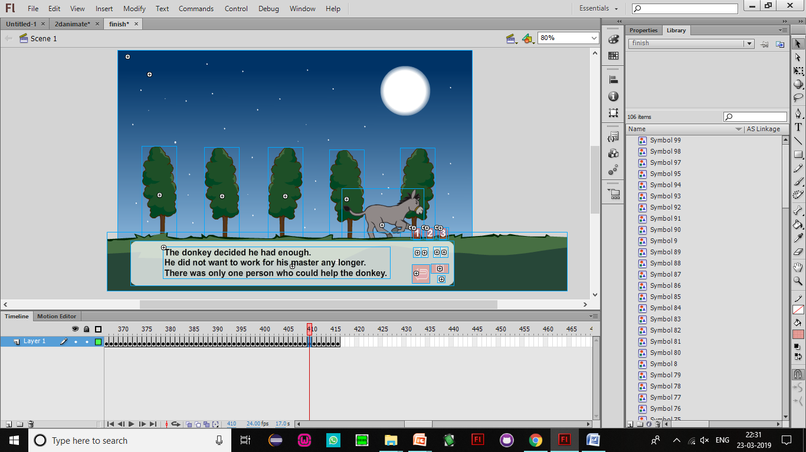

REFERENCES:

<https://helpx.adobe.com/in/animate/using/symbols.html>

<https://smartwebby.com/Flash/flash_symbols.asp>

<http://www.flashkit.com/movies/>

<https://www.dummies.com/software/adobe/flash/how-to-create-frame-by-frame-animation-in-adobe-flash-cs6/>

<http://edutechwiki.unige.ch/en/Flash_frame-by-frame_animation_tutorial>

THANK YOU!